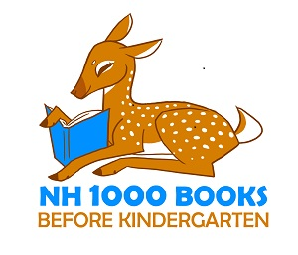

Child’s Name

Children need to hear a thousand stories before they can begin to learn to read. Or the same story a thousand times!”
Children’s author Mem Fox, from her “Ten Read-Aloud Commandments”

Early childhood experts have confirmed that the more time you read to your child, the more prepared and eager they will be when it comes time for them to learn to read by themselves. 1000 books may seem like a daunting number, but consider: if you read one story a day to your child, you’d complete 365 in one year. By the time your child is 3 years old, you’ll have greatly exceeded the 1K mark. So get started today!
Belmont Public Library
146 Main Street
(603) 267-8331
www.belmontpubliclibrary.org

1000 Books Before Kindergarten—Color-In Log
Every time you read a story to your child, have him or her color a book or put a sticker or stamp on it. Remember: If you read the same book repeatedly, it counts each time!

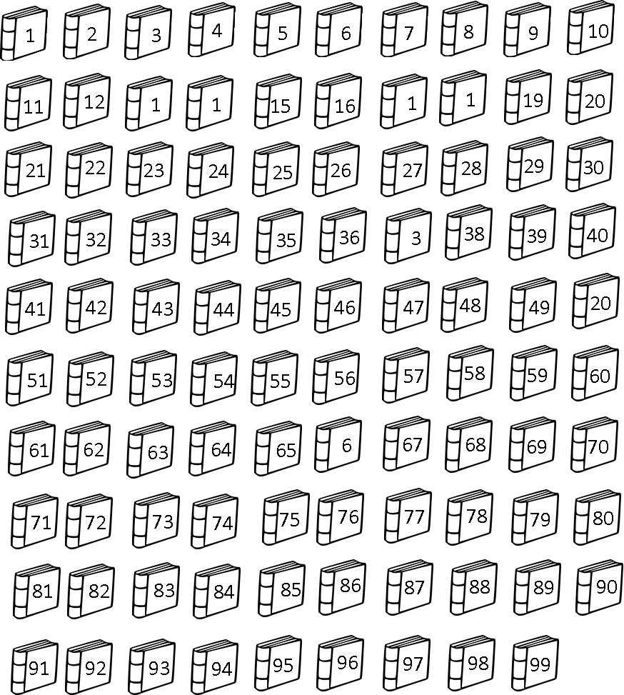Congratulations! You’ve read 100 books!
Bring your log to the library to receive a prize and get your next log.
100!

