1000 Books Before Kindergarten
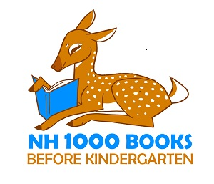
“Children need to hear a thousand stories before they can begin to learn to read. Or the same story a thousand times!” - Children’s author Mem Fox
Early childhood experts have confirmed that the more you read to children, the more prepared and eager they will be when it comes time for them to learn to read independently. 1000 books may seem like a daunting number, but consider: if you read one story a day to your child, you’d complete 365 in one year. By your child’s 3rd birthday, you’ll have greatly exceeded the 1K mark. So get started today! Each time you read a story to your child, log the title of the book here. If you read the same book repeatedly, it counts each time!
Chil

Child’s Name: ___________________________________________________
Write the titles of the books that you read to your child on the lines below:
1. | 2.
3. | 4.
5. | 6.
7. | 8.
9. | 10.
11. | 12.
13. | 14.
15. | 16.
17. | 18.
19. | 20.
21. | 22.
23. | 24.
25. | 26.
27. | 28.
29. | 30.
Continued on Back…
Belmont Public Library

31. | 32.
33. | 34.
35. | 36.
37. | 38.
39. | 40.
41. | 42.
43. | 44.
45. | 46.
47. | 48.
49. | 50.
51. | 52.
53. | 54.
55. | 56.
57. | 58.
59. | 60.
61. | 62.
63. | 64.
65. | 66.
67. | 68.
69. | 70.
71. | 72.
73. | 74.
75. | 76.
77. | 78.
79. | 80.
81. | 82.
83. | 84.
85. | 86.
87. | 88.
89. | 90.
91. | 92.
93. | 94.
95. | 96.
97. | 98.
99. | 100.

Congratulations! You’ve read 100 books! Bring this sheet to the library to receive a prize and to get your next log!

