Friends 2022 Proposed Budget
MISSION

Friends of the Jonathan Bourne Public Library is a not for profit 501 c 3 corporation. It is the mission of the Friends to enhance the resources of the Library and to encourage all members of our community to benefit from the Library.
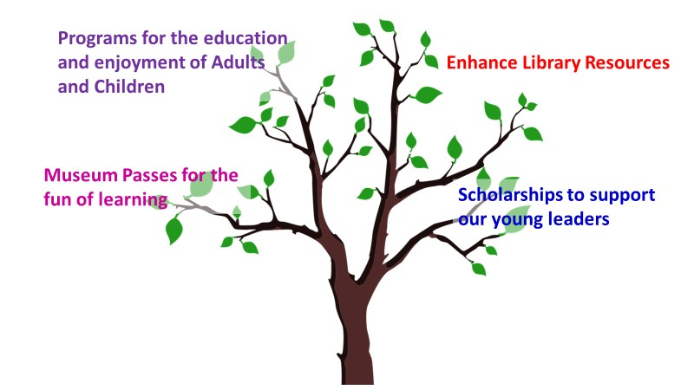
We raise funds for our services through donations from businesses and individuals, membership dues and fundraising activities. In addition, we supplement our funding through profits from a brokerage account that was established in 1998.

Budget Review & Proposed 2022 Budget
The Budget of 2021 will be remembered as a Covid Budget. The Library building was closed, services continued, but programs could not be held in the building. Museums closed and museum pass renewals did not occur as in prior years. With the 2022 Budget we seek to:
- Return to a strong schedule of Adult and Children Programs, and
- Launch a Library Improvement Campaign to upgrade certain areas within the Library.

Proposed 2022 Budget
- Expenses
Expenses 2021 Amended Budget - Based on Year End Forecast 2022 Budget  Adult Programs $3,575 $7,000  Children Programs $4,767 $8,500  Museum Passes $5,045 $5,000  Scholarships $5,000 $4,500  Equipment, Software & Online Services $3,686 $3,500  Office & Other $3,138 $3,500  Total to Fund $25,211 $32,000  Brokerage Fee $7,181 $7,200  Note: The Brokerage fee is withdrawn from the fund by the bank to cover the costs of managing the account. Therefore, this cost does not need to be raised as Income. | Expense Assumptions from 9/4/21 to 12/31/21:  The proposed Budget will increase funding for Adult and Children Programs.  See below for Museum Pass details.  Three $1,500 scholarships were awarded in June of 2021 and will be paid in 2022.  Equipment, Software & Online Services funding includes: $2,500 for Book Page and Zoobean.  Office funding includes $564 for insurance, funds for supplies, food and other miscellaneous items.

Museum Passes

The following list of museums are those that Friends have paid for in prior years. The overall cost of this program in the Budget is rounded down from $5,046 to $5,000.

Museum Passes | $
Boston Children's | $700
Buttonwood Park Zoo | $350
Cape Cod Children's Museum | $400
Cape Cod History of Natural History | $200
Edaville (currently closed) | $600
Heritage Museum & Garden | $350
Historic New England | $125
Isabel Stewart Gardener | $196
Museum of Fine Arts | $475
New England Aquarium | $650
Plimoth Plantation & Mayflower | $500
Roger Williams Zoo Park | $250
Zoo New England | $250
Total | $5,046

- Income
Income 2021 Amended Budget - Based on Year End Forecast 2022 Budget  Dues $2,370 $2,400  Donations $3,066 $3,500  Fund Raising $3,257 $3,500  Brokerage Account $17,000 $23,000  Checking Account $6,699 $0  Total $32,392 $32,400 | Income Assumptions from 9/4/21 to 12/31/21:  The proposed Budget assumes that dues and donations will remain the same.  Fund Raising through Book Sales is based on two major book sales.  A withdrawal of $23,000 is proposed from the Brokerage account for 2022. See chart below for further details.

Brokerage Account Information

The following chart provides a summary of the history of the funds in the Brokerage account.

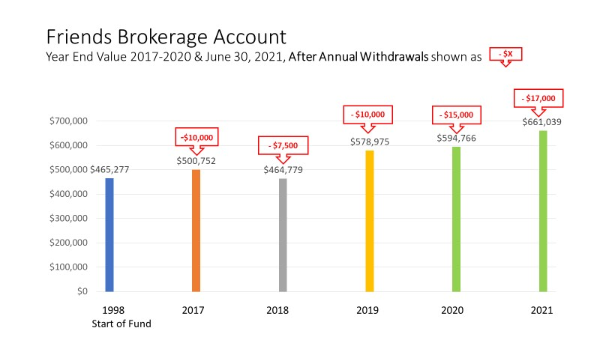
The 2022 Budget uses the July 2021 value of the Brokerage account as its reference point. As shown above, the account has a value of $661,039. This is $66,273 greater than the end value of the account on 12/31/20. The proposed withdrawal for 2022 is $23,000 is within the growth margin of the account.

NOTE: Friends also has three Building Fund CDs. The use of these funds is restricted to a future expansion of the Library. The value of these funds on 8/1/21 was $116,537.

- Special Library Improvement Campaign

Library staff has requested important upgrades for the community meeting room and a few other areas in the Library. These improvements will enhance the services that can be provided to the community. Expenditures for these improvements would be dependent upon raising these funds. An outreach program to Bourne businesses is recommended.

Library Improvement Campaign | Goal | Includes
Community Meeting Room | $35,000 | 60 stackable chairs, AV equipment, blackout drapes, donor recognition
Staff Room | $8,000 | Furniture
Community Creative Work Area | $2,000 | Printer, Cricut machine, etc.
Total Fund-Raising Goal | $45,000

Note: This proposed campaign will depend on the identification of volunteer leadership. Adoption of the 2022 Budget does not fund this work. Rather it includes this campaign as a major objective for the Friends organization in 2022.

