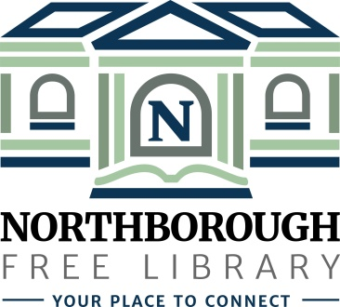 | Northborough Free Library  34 Main Street  Northborough, MA 01532-1997  Phone: (508) 393-5025  www.northboroughlibrary.org

Board of Library Trustees

AGENDA
Tuesday, September 10, 2019
7:00 p.m.

Conference Room

- Call to order and opening remarks

- Approval of minutes of July 9, 2019

- Treasurer’s Report
  - 2019 Annual Trust Fund Review (Bartholomew & Co.)

- Appropriations Reports:
- FY2019 Appropriations Report
- FY2020 Appropriations Report

- Library Director’s Report
- Personnel update
- Restoration of Thursday evening hours (January 2020)
  - Proposed Agreement: Transfer of funds to the Town
- Building update: Repair of the Gale Library Building
- FY2019 Annual Statistical Usage
- Request from US Census to use meeting room space
- Update on Friends of the Library Board
- Applefest Parade and Street Fair Booth: September 21st – 22nd

- Committee Reports:
- Administrative Committee
  - Bylaws review
  - Revised Collection Development Policy
- Long Range Planning Committee
  - Proposed FY2020 – FY2021 Action Plan
- Building and Grounds Committee
- Technology Committee
- Development Committee

- Any other business that may come before the Board

- Adjournment

