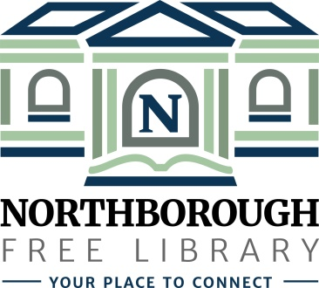 | Northborough Free Library  34 Main Street  Northborough, MA 01532-1997  Phone: (508) 393-5025  www.northboroughlibrary.org

Board of Library Trustees

AGENDA
Tuesday, March 12, 2019
7:00 p.m.

Conference Room

- Call to order and opening remarks

- Approval of minutes of February19, 2019

- FY2019 Appropriations Report

- Library Director’s Report
- Building update
- Presentation of Building and Space Planning Survey results
- Recommendation to post an RFP in order to retain a building consultant
- Presentation of the Proposed FY2020 Budget to the Town’s Appropriations Committee on March 14, 2019

- Committee Reports:
- Administrative Committee – no report
- Long Range Planning Committee – no report
- Building and Grounds Committee
- Technology Committee
- 150th Anniversary Committee:
  - 150th Jubilee on April 6, 2019
- Development Committee:
  - Update on 2018 annual appeal mailing and donor recognition
  - Next steps in fundraising & development plan
  - Next steps on planned giving program

- Date of next meeting: April 9, 2019

- Any other business that may come before the Board

- Adjournment

