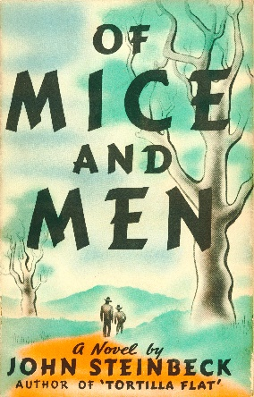
Amelia
Of Mice and Men by John Steinbeck
John Steinbeck's adventurous novel revolves around the story of two best friends during the great depression. Together, they face the hardship of life and the struggles that are thrown at them.

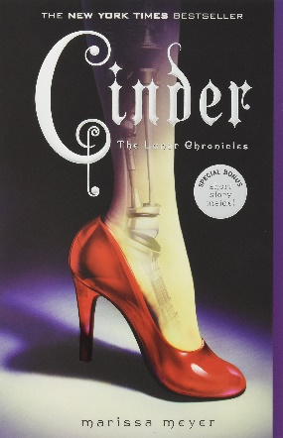
Calista
Cinder by Marissa Meyer
A cyborg mechanic in a futuristic city: what must she do to help save the world from a lunar invasion? A unique take on the story of Cinderella. First in the series.

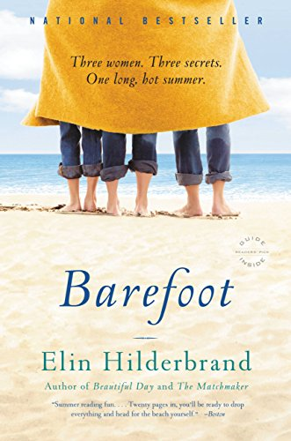
Eileen
Barefoot by Elin Hilderbrand
Every summer I look forward to a trip to Nantucket courtesy of Elin Hilderbrand. Thanks to her, I feel like I know this island’s well-off summer residents and storied landscape. Barefoot is the first book of Elin’s I ever read. Plot doesn’t really matter – it’s the feeling. May I also recommend her newest book, Golden Girl?

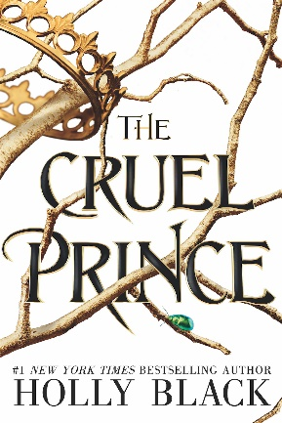
Kelly H
The Cruel Prince by Holly Black
Jude Duarte is a fish out of water. Well, more accurately she’s a mortal in the Court of Faerie. Surrounded by beautiful creatures who can never die, Jude and her sister Taryn must kneel before royalty or face the consequences, including near-fatal harassment at the hands of Prince Cardan and his gang of ruffians. But Jude fights back with her uniquely human skill set, landing her in a heated battle for royal power. Her own rag-tag family, consisting of her hopeless romantic twin sister Taryn, her half-Faerie half-sister Vivi, her murderous step-father Madoc, her over-protective step-mother Oriana, and Oriana’s child, Oak, begins to tear at the seams. This book begs the question, “To whom do you bend the knee, and to whom do you stand?”

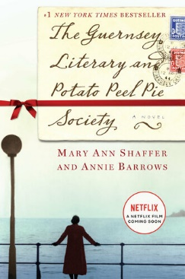
Kelly R
The Guernsey Literary and Potato Peel Pie Society by Mary Ann Shaffer
At the end of World War II writer Juliet Ashton is looking for her next book subject and who would guess she would find it in a letter from a man from Guernsey, the British island once occupied by the Nazis. As they correspond she gets to know this man and his group of friends in the Guernsey Literary and Potato Peel Pie Society, a unique book club formed as a result of the German occupation. I have enjoyed both this book and the movie - which was very well done - but, of course, recommend reading the book first.

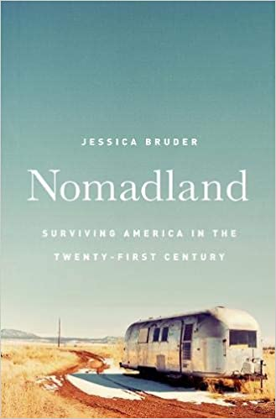
Linda
Nomadland: Surviving America in the Twenty-First Century by Jessica Bruder
The author writes about what she knows…firsthand. Bruder traveled with America’s modern day nomads and her observations come to life by way of the personal relationships she formed as part of this tribe of independent individuals. One of the largest employers of these aging nomads is Amazon. National and State Parks also vie for these experienced and reliable workers. The nomads are inventive and many people experience a deep sense of freedom: from mortgages and other obligations. Provocative and insightful.

