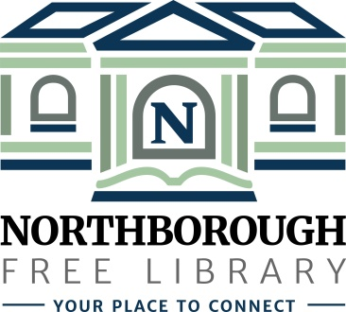 | Northborough Free Library  34 Main Street  Northborough, MA 01532-1997  Phone: (508) 393-5025  www.northboroughlibrary.org

Board of Library Trustees

AGENDA
Tuesday, July 9, 2019
7:00 p.m.

Conference Room

- Call to order and opening remarks
- Welcome to our new Trustee

- Approval of minutes of May 14, 2019

- Treasurer’s Report: Update on Trust Funds

- FY2020 Appropriations Report

- Library Director’s Report
- Personnel update
  - Memo: Reference & Adult Services position
- Building update: Repair of Gale Library Building
- Outreach Services Coordinator position
- Friends: Apple Memory Café
- AppleFest Parade and Street Fair Booth: September 21st – 22nd

- Committee Reports:
- Administrative Committee
  - Bylaws review
  - Revised Collection Development Policy
- Long Range Planning Committee
- Building and Grounds Committee
- Technology Committee
- 150th Anniversary Committee
  - Time Capsule Sealing: July 16th @ 6:00 p.m.
- Development Committee

- Any other business that may come before the Board

- Adjournment

