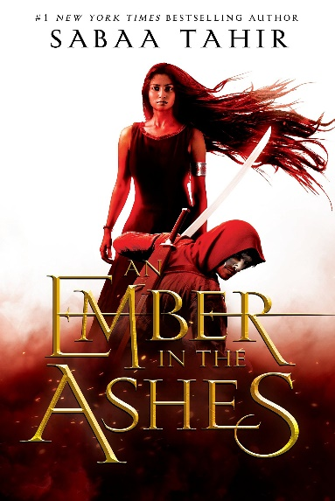
Calista recommends An Ember in the Ashes by Sabaa Tahir
Laia and her brother are orphans after their parents are slaughtered for leading the Resistance. Now her brother has been arrested and Laia will do everything she can to save him. Even if that means going under cover as a slave at the most powerful military academy in the empire. Elias is the academy’s rising star. He secretly hates it and wants to run away. Before he manages to escape, he is ordered into a terrifying and deadly contest that will choose the next emperor. When Laia and Elias meet they are immediately drawn to one another in their time of need. Will Laia be able to help Elias escape? Can Elias help Laia rescue her brother? Or will the empire destroy them all?
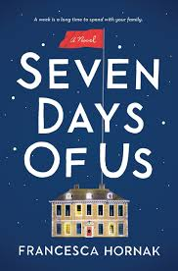
Available through the Libby app with your library card.
Eileen recommends Seven Days of Us by Francesca Hornak
It’s Christmas, and for the first time in years, the entire Birch family will be under the same roof. Olivia, the elder daughter, is coming home from a medical mission in Liberia—and she’s been told to quarantine at home for a whole week. For the next seven days, the Birches are locked down, cut off—even from decent wifi. This enforced closeness brings secrets to the surface—and that’s before the unexpected visitor arrives. . .
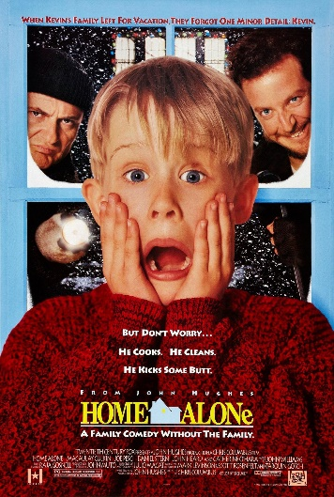
Kelly recommends Elf and Home Alone
Yes – I cannot decide which is my favorite and so I am recommending both of these holiday movies. I am thinking it is a good time to sit and enjoy a couple of classics and have a good walk down memory lane and more than a few belly laughs. I am so in the mood for some good old-fashioned escapism into the silly world of Elf and Kevin. I don’t feel the need to recap these two movies, Elf and Home Alone, as most have already seen them but would like to encourage everyone to think outside the box when borrowing once in a while and revisit an old favorite. We have several other holiday movies and a generous collection of holiday inspired books. Add a cup of hot cocoa and a bowl of popcorn and it’s the perfect recipe for snuggling in and enjoying our winter time indoor time. I am looking forward to it. 🎅

Linda recommends On The Basis of Sex
Ruth Bader Ginsburg’s (RBG) cameo appearance at the end of the film is evidence of her approval and support of the content as well as the performance of Academy Award Nominee, Felicity Jones. Jones introduces viewers to a young RBG enrolled in law school and the start of her career. The challenges RBG faced in law school and in establishing her career were formidable. All viewers, including viewers who lived through the time period portrayed (1950s-1970s), will find the inequities and injustices to be shocking. RBG’s legacy endures in the more than 300 cases she participated in that led to landmark changes in American Constitutional Law.
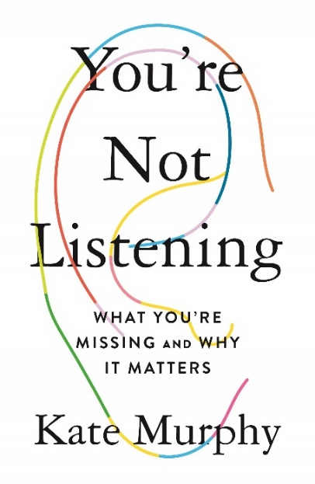
Sarah recommends You're Not Listening: what you're missing and why it matters by Kate Murphy
When was the last time you listened to someone? I mean really listened...you put away your phone, didn't offer advice, didn't plot your response, and simply let someone speak. Journalist Kate Murphy interviews professional listeners and examines what listening really is while sharing the science behind and the importance of deep listening.

