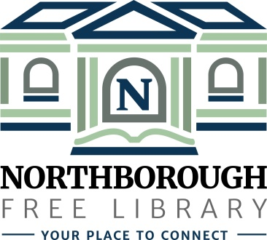 | Northborough Free Library  34 Main Street  Northborough, MA 01532-1997  Phone: (508) 393-5025  www.northboroughlibrary.org

Board of Library Trustees

AGENDA
Tuesday, February 19, 2019
7:00 p.m.

Conference Room

- Call to order and opening remarks

- Approval of minutes of January 8, 2019

- FY2019 Appropriations Report

- Library Director’s Report
- Personnel update
- Building update
- Spring 2019 programs
- Northborough Cultural Council Grantee Reception: February 13, 2019
- Library Legislative Day at the Mass. State House: March 5, 2019

- Committee Reports:
- Administrative Committee – no report
- Long Range Planning Committee – no report
- Building and Grounds Committee
  - Review of Building & Space Planning Survey results pending
- Technology Committee
  - Wireless printing with MobilePrint
- 150th Anniversary Committee:
  - 150th Jubilee on April 6, 2019
- Development Committee:
  - Update on 2018 annual appeal mailing
  - Next steps in fundraising & development plan

- Date of next meeting: March 12, 2019

- Any other business that may come before the Board

- Adjournment

