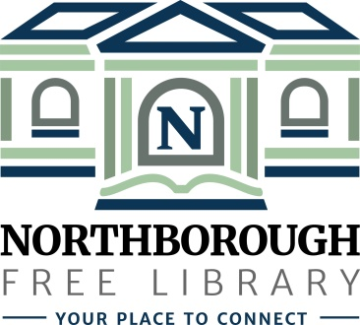 | Northborough Free Library  34 Main Street  Northborough, MA 01532-1997  Phone: (508) 393-5025  www.northboroughlibrary.org

Board of Library Trustees

AGENDA
Tuesday, November 13, 2018
7:00 p.m.

Conference Room

- Call to order and opening remarks
- Update on open Trustee seat
- New MBLC Trustee Handbooks
- Mass. Library Trustees Association meeting on November 17th @ 9:30 a.m.

- Approval of minutes of October 9, 2018

- Library Director’s Report
- Review Proposed FY2020 Budget
- FY2018 usage statistics included in Annual Report Information Survey (ARIS)
- Revisit proposed policy on issuing library cards to out-of-state residents

- Committee Reports:
- Administrative Committee:
  - Proposed Bylaws review
- Long Range Planning Committee – no report
- Building and Grounds Committee:
  - Update on public procurement for repair of Gale Library using CPA funds
  - Proposed restoration of the pocket doors in the Gale Library using CPA funds
  - Update on building & space planning survey
- Development Committee:
  - Update on Planning Study with Carlton & Co.
  - Update on 2018 annual appeal mailing
- 150th Anniversary Committee:
  - 150th Jubilee on April 6, 2019
  - Update on meeting with Friends of the Library Board on October 31, 2018
- Technology Committee:
  - Update on proposed wireless print solution (Canon USA)

- Date of next meeting: December 11, 2018

- Any other business that may come before the Board

- Adjournment

