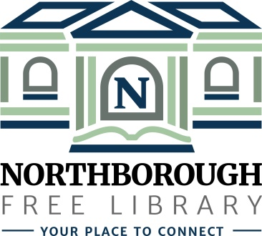 | Northborough Free Library  34 Main Street  Northborough, MA 01532-1997  Phone: (508) 393-5025  www.northboroughlibrary.org

Board of Library Trustees

AGENDA
Tuesday, December 11, 2018
7:00 p.m.

Conference Room

- Call to order and opening remarks

- Approval of minutes of November 13, 2018

- Library Director’s Report

- FY2019 Appropriations Report

- Committee Reports:
- Administrative Committee – no report
- Long Range Planning Committee – no report
- Building and Grounds Committee – no report
- Technology Committee – no report
- 150th Anniversary Committee:
  - 150th Jubilee on April 6, 2019
- Development Committee:
  - Update on 2018 annual appeal mailing

- Presentation of Planning Study Report by Carlton & Company

- Date of next meeting: January 8, 2019

- Any other business that may come before the Board

- Adjournment

