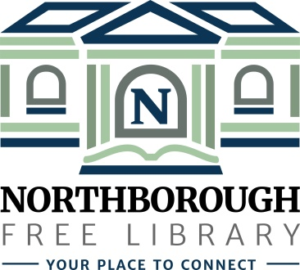 | Northborough Free Library  34 Main Street  Northborough, MA 01532-1997  Phone: (508) 393-5025  www.northboroughlibrary.org

Board of Library Trustees

AGENDA
Tuesday, July 10, 2018
7:00 p.m.

Conference Room

- Call to order and opening remarks
- Update on open Trustee seat

- Approval of minutes of June 12, 2018

- Library Director’s Report
- Personnel update
- Building update
- Proposed agreement with Better World Books
- Request to use children’s program room for birthday parties
- Online community calendar: Burbio.com

- Committee Reports:
- Administrative Committee – no report
- Long Range Planning Committee – no report
- Building and Grounds Committee
  - Customer survey and focus group meetings
  - Next meeting: July 24, 2018 @ 7:00 p.m.
- Development Committee:
  - Proposed updated agreement with Carlton & Co.
  - Update on establishment of an endowment fund
  - Proposed MOU with the Friends of the Library
  - Next meeting: TBD
- 150th Anniversary Committee
  - Proposed 150th Anniversary Gala on April 6, 2019
  - Applefest Parade and Street Fair (September 15-16, 2018)
  - Next meeting: July 17, 2018 @ 6:30 p.m.
- Technology Committee – no report

- Date of next meeting: September 11, 2018

- Any other business that may come before the Board

- Adjournment

