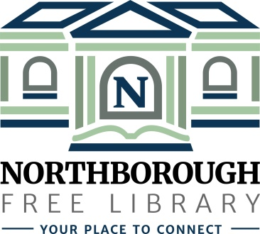 | Northborough Free Library  34 Main Street  Northborough, MA 01532-1997  Phone: (508) 393-5025  www.northboroughlibrary.org

Board of Library Trustees

AGENDA
Tuesday, October 9, 2018
7:00 p.m.

Conference Room

- Call to order and opening remarks
- Open Trustee seat
- Friends of the Library Board

- Approval of minutes of September 11, 2018

- Library Director’s Report
- Preliminary Proposed FY2020 Budget
- Building update
- Proposed policy regarding issuing library cards to out-of-state residents

- Committee Reports:
- Administrative Committee:
  - Proposed Bylaws review
- Long Range Planning Committee – no report
- Building and Grounds Committee:
  - Update on public procurement for repair of Gale Library using CPA funds
  - Proposed restoration of the pocket doors in the Gale Library using CPA funds
  - Update on building & space planning survey
- Development Committee:
  - MOU between the Trustees and the Friends of the Library
  - Establishment of agency fund at the Greater Worcester Community Foundation
  - Update on Planning Study with Carlton & Co. and request for assistance
  - Annual appeal mailing
- 150th Anniversary Committee:
  - 150th Jubilee on April 6, 2019
  - Gale Library Exhibit (November – December, 2018)
- Technology Committee:
  - Proposed technology expenses in FY2020 Budget
  - Proposed wireless print solution (Canon USA)

- Date of next meeting: November 13, 2018

- Any other business that may come before the Board

- Adjournment

