February Staff Picks
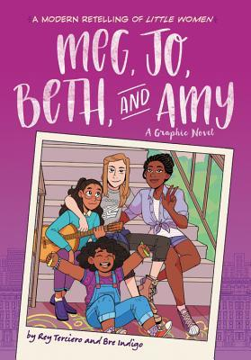Amelia recommends Meg, Jo, Beth, and Amy: A Graphic Novel by Rey Terciero and Bre Indigo
Terciero has brought us this truly wholesome and sweet family graphic novel. The warmth that you get reading this book truly inspires you. This novel teaches kids to be grateful for what they have, and spread the lesson of also being able to accept who you are.
Meg, Jo, Beth, and Amy are all sisters. Even though they’re not all biological, they all grew up together and have a strong bond. With their father overseas in the military and their mom having to work extra shifts to keep them up in payments, the girls have to teach themselves about growing up. The two oldest are trying their hardest to be there for their younger sisters while also keeping each other grounded among the challenges of school, work, and personal issues. Read to join along with this very comedic and heartfelt story. I’m sure you’ll enjoy it!
Calista recommends the movie, The Call of the Wild
Based on the novel by Jack London, The Call of the Wild is a story about a smart, loveable, silly dog named Buck. When Buck is dog-napped and sent to the wilds of the Alaskan Yukon, his whole life changes. He becomes part of a mail delivery sled dog team where he learns to become one of the pack. Come along with Buck as he slides from one adventure to the next and finds his true place in the world.

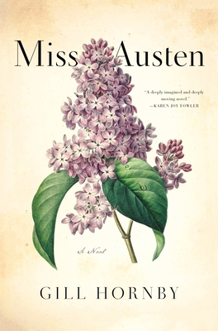Eileen recommends Miss Austen by Gill Hornby
Miss Austen is not Jane, she of worldwide fame for six brilliant novels. Miss Austen is Cassandra, the quietly protective older sister whose only concern after her sister's early death was to protect that literary reputation. Cassandra, now in her sixties, is in search of letters containing the details of events now long ago-- but still deeply relevant to Cassandra's own feelings and standing in the community. What will Cassandra sacrifice to protect her beloved sister's legacy?
Gill Hornby's story, moving back and forth in time, is a convincing interpretation of the Austen sisters' stories. The writing lends warmth and depth to the historical character of Cassandra. There is also just a hint that the truth may lie beyond the bounds of the story.

February Staff Picks
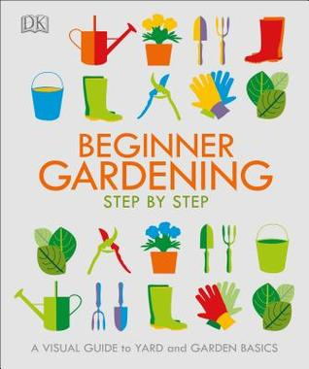Kelly recommends Beginner Gardening Step by Step by DK Publishing
Even though it is only January it is already time to gather information, seeds, gardening gear, etc. for the 2021 gardening season. Similar to 2020, the gathering of gardening goodies is beginning much earlier than usual due to more people having time at home these days. I admit to beginning my planning after the holiday season, honestly, just because it was a welcome distraction and I love the thought of something new and beautiful growing in these short cold days of winter. This book is a very basic how-to with beautiful photographs to encourage even the faint of heart to try their hand at gardening. I also found it a nice refresher course. This is not just limited to vegetable and flower gardens though, there are great sections on lawns, shrubs, small trees, and a section on practicalities too (i.e. making your own compost, pruning, troubleshooting weeds, etc.) So think green and warmer temperatures and getting outside and digging in the dirt, but in the meantime do some planning with a great gardening book like this one. Also check out our other books in our gardening section in non-fiction.
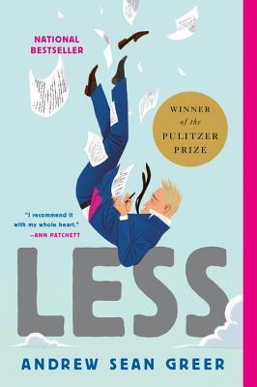
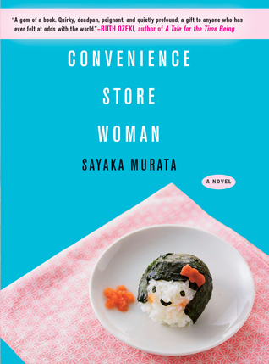Linda recommends Convenience Store Woman by Sayaka Murata
There is a lot of magic and wisdom contained in this novel. Finding one’s place in life and being comfortable in one’s skin is a journey that each person embarks on.
Working at a convenience store is the only job Furukura has ever had. At thirty-six years of age she is single with no interest in sex or finding a mate. Her sister, mother, and co-workers would like her to conform to societal norms. Instead, her allegiance is to the store and the customers. In all ways Furukura is a model employee.
The story gives readers pause to consider the many ways individuals may adopt the behavior and characteristics of others in order to fit in. It is interesting to consider how one’s individuality may in fact be derived from bits and pieces borrowed from others.
Sayaka Murata is the author of numerous books and has been recognized with Japan’s most prestigious literary award, the Akutagawa Prize. In addition to writing, she continues to work in a convenience store.
Sarah recommends Less by Andrew Sean Greer
“His brain sits before its cash register again, charging him for old shames as if he has not paid before."
Arthur Less, an aspiring novelist, is approaching 50 and feels like a failure. When he receives a wedding invitation from a long-time ex-boyfriend he panics and goes on a once in a life-time adventure. This funny, light-hearted Pulitzer winner is a gentle reminder that it's ok to start over and that true love starts with a journey of self-love. Bonus: If you enjoy Arthur Less and his foibles, you can follow him on a new adventure in November 2021.

