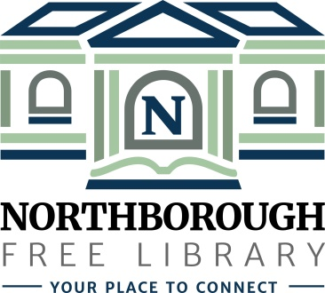 | Northborough Free Library  34 Main Street  Northborough, MA 01532-1997  Phone: (508) 393-5025  www.northboroughlibrary.org

Board of Library Trustees

AGENDA
Tuesday, February 13, 2018
7:00 p.m.

Conference Room

- Call to order and opening remarks

- Approval of minutes of December 12, 2017

- Approval of minutes of January 9, 2018

- Financial Report
- FY18 Appropriations – January 2018

- Library Director’s Report
- Building update
- Town Annual Report for 2017
- LSTA grant: Outreach Services
- Patron Behavior Policy
- Roving Archivist Grant

- Committee Reports:
- Development Committee
  - Committee meeting on March 12, 2018
  - Update on 2017 annual appeal
  - Update on establishment of an endowment fund
- 150th Anniversary Committee
  - Committee meeting on February 6, 2018
  - 150th Birthday Party on April 8, 2018
- Building and Grounds Committee
  - Space planning meeting on January 23, 2018
  - Space planning meeting on February 20, 2018

- Date of next meeting: March 13, 2018

- Any other business that may come before the Board

- Adjournment

