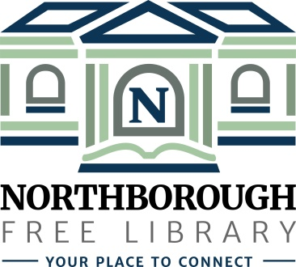 | Northborough Free Library  34 Main Street  Northborough, MA 01532-1997  Phone: (508) 393-5025  www.northboroughlibrary.org

Board of Library Trustees

AGENDA
Tuesday, January 8, 2019
7:00 p.m.

Conference Room

- Call to order and opening remarks

- Approval of minutes of December 11, 2018

- FY2019 Appropriations Report

- Library Director’s Report:
- Proposed holiday closings in 2019
- Recommended policy: Accepting valid government-issued photo
ID in lieu of library card
- 2018 Annual Report – Town of Northborough
- Town of Northborough’s Classification and Compensation Study
- FY2019 State Aid award
- Library Legislative Breakfast: February 8 at 8:00 a.m.

- Committee Reports:
- Administrative Committee – no report
- Long Range Planning Committee – no report
- Building and Grounds Committee – no report
- Technology Committee – no report
- 150th Anniversary Committee:
  - 150th Jubilee on April 6, 2019
- Development Committee:
  - Review Capital Fundraising Study Report
  - Update on 2018 annual fund appeal

- Date of next meeting: February 12, 2019

- Any other business that may come before the Board

- Adjournment

