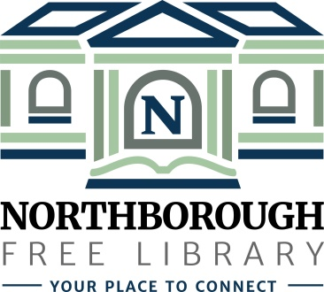 | Northborough Free Library  34 Main Street  Northborough, MA 01532-1997  Phone: (508) 393-5025  www.northboroughlibrary.org

Board of Library Trustees

AGENDA
Tuesday, January 9, 2018
7:00 p.m.

Conference Room

- Call to order and opening remarks

- Guest Presentation: Kelly Stimson, Greater Worcester Community Foundation

- Approval of minutes of December 12, 2017

- Financial Report
- FY18 Appropriations - November 2017
- FY18 Appropriations - December 2017

- Library Director’s Report
- Personnel update
- Building update
- LSTA grant: Outreach Services
- Finding Common Ground: Disaster Planning training

- Committee Reports:
- Development Committee
  - Committee meeting on January 8, 2018
  - Update on 2017 annual appeal
- 150th Anniversary Committee
  - Committee meeting on January 16, 2018
- Building and Grounds Committee
  - Space planning meeting on January 23, 2018
  - MBLC Building Consultant Lauren Stara

- Date of next meeting: February 13, 2018

- Any other business that may come before the Board

- Adjournment

