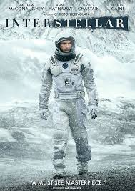
Amelia recommends Interstellar
Interstellar is a brilliant sci-fi movie brought to screen by Christopher Nolan. A heartbreaking film following NASA physicist Joseph Cooper, who heads to space to look for a planet suitable for human habitation and his genius daughter Murph, who grows up wondering how to bring her father home. Joseph Cooper leads a group of very smart scientists to travel through a wormhole in search for a planet habitable for human life. They are sent to try out two different planets to figure out which one is truly better than the other. This movie is a mind twisting yet heartfelt movie.
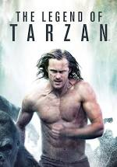
Calista recommends The Legend of Tarzan
Tarzan no longer lives in the jungle. He now lives in Europe as John Clayton III, Lord Greystroke. Jane, the love of his life, is still by his side. When John gets an invitation from the King to visit his new schools in Africa, he is hesitant to go. Jane convinces him they should go, to visit both of their homelands. They do not know till it is almost too late that they have been tricked by a very eccentric, evil man, Captain Leon Rom. Though Rom is in for his own surprise when he sees what cornering John will do. The real Tarzan emerges in a fury and everything in his path better watch out.

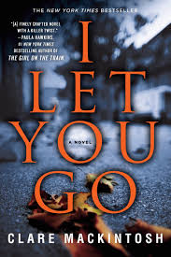
Eileen recommends I Let You Go by Clare Mackintosh
A tragic accident. It all happened so quickly. She couldn't have prevented it. Could she?
In a split second, Jenna Gray's world descends into a nightmare. Her only hope of moving on is to walk away from everything she knows to start afresh. Desperate to escape, Jenna moves to a remote cottage on the Welsh coast, but she is haunted by her fears, her grief and her memories of a cruel November night that changed her life forever. Slowly, Jenna begins to glimpse the potential for happiness in her future. But her past is about to catch up with her, and the consequences will be devastating . . .
I love the twists and turns of Clare Mackintosh’s stories, but this book is not for everyone, as it involves descriptions of a fatal car accident and emotional abuse.

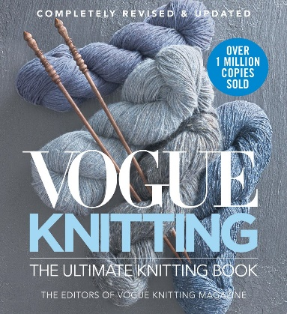
Kelly recommends Vogue Knitting: The Ultimate Quick Reference by editors of Vogue Knitting Magazine
With the brisk fall weather upon us and winter nesting season right behind I, like many other fiber enthusiasts, have already begun to enjoy one of my indoor hobbies, knitting. I am thrilled to rediscover a book that was new to BPL shortly before the pandemic and I don’t feel received enough attention: The completely revised and updated Vogue Knitting: The Ultimate Quick Reference. A great little knitting reference with wonderful simple illustrations that will take you from basic techniques such as casting on to advanced techniques such as knitting shapes (triangles, squares), brioche knitting. Also included in this knitting resource book are beginner instructions on stitch gauge, knitting terminology, correcting errors, finishing and much more.
Whether a beginner or someone needing a refresher a compact and well-illustrated manual for everyday knitting projects. Oh, and lest I forget, there are even some patterns along with a needle gauge (holes) and measuring ruler at the back of the book.

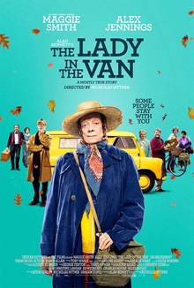
Linda recommends The Lady in The Van: A Mostly True Story
The movie is an adaptation of Alan Bennett’s 2014 memoir by the same title. The author befriended Miss Shepard and allowed her to temporarily park her van in his driveway. For the next 15 years Miss Shepard lived in her home – her van – which remained parked in Bennett’s driveway. Glimpses into Miss Shepard’s past let viewers look beyond the disheveled, eccentric “old woman.” Everyone has a past and viewers are introduced to a young Miss Shepard – a vibrant woman with a passion for music. Her talents were recognized and she was a student of a world-renowned composer. Throughout her life Miss Shepard was a devout Catholic. Viewers will form their own opinions as to the way in which the church influenced Miss Shepard’s life. The extraordinary actress Maggie Smith becomes Miss Shepard. Viewers get a glimpse of many of the hardships of living life on one’s terms as Miss Shepard insisted upon. Miss Shepard became part of the fabric of the north London neighborhood which she called home. The setting of the film is the area in which Miss Shepard lived. After her death Bennett installed a plaque outside his home honoring the life of Miss Shepard.
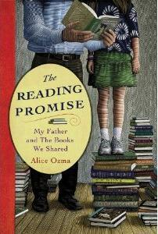
Sarah recommends The Reading Promise: My Father and the Books We Shared by Alice Ozma
In this affecting memoir, Alice and her Father, an elementary school librarian, make a promise to read together for 100 consecutive nights. When they reach their goal they both realize that they don't want to stop so they set a new goal of 1,000 consecutive nights which they far surpass.

