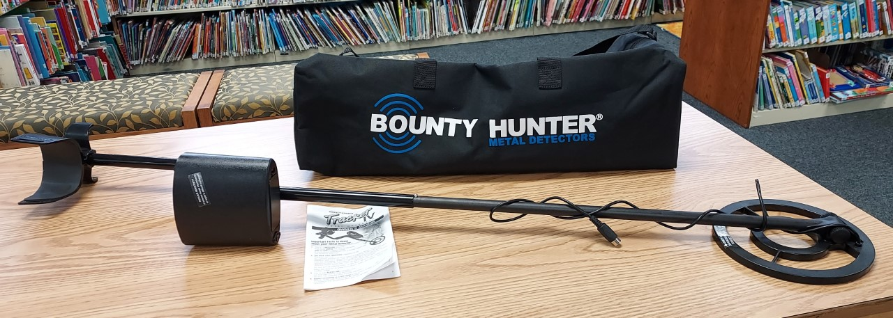

METAL DETECTOR
4 PIECES TOTAL
4 BARCODES TOTAL
39900000707303 – BAG
39900000707139 – TOP PART OF UNIT
39900000707220 – BOTTOM PART OF UNIT
39900000707048 – OWNER’S MANUAL/DIRECTIONS

